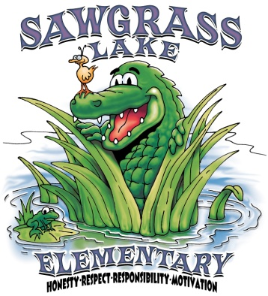**Sawgrass Lake Elementary**

**1815 - 77th Avenue North St. Petersburg, FL 33702**

Jessica Clements Cyndi Ingalls LaShawn Proctor

Principal Secretary/Bookkeeper Assistant Principal

Title 1 Parent/Student/Teacher Compact

2019-2020

**As a parent/guardian, I pledge to:**

* See that my child is at school **daily, on time and for the full day**
* Provide a home environment that encourages learning
* Be informed by talking with my child, checking assignments/homework and folder/agenda for notices of school events on a daily basis
* Attend conferences as requested and family events when possible
* Refer to Pinellas County Code of Conduct to increase awareness of discipline and parent expectations
* Encourage my child to take responsibility for his/her actions
* Maintain open lines of communication with the teacher and school
* Provide time for my student to complete homework and read daily

Parent Signature: ___________________________________ Date: _________________

**As a student, I pledge to:**

* Follow school wide rules every day
* Follow the Pinellas County Code of Conduct guidelines for school and bus
* Come to school on time and with all of my materials
* Complete homework and read daily
* Believe that I CAN and WILL learn
* Help maintain a safe environment

Student Signature: ___________________________________ Date: _________________

**As a teacher, I pledge to:**

* Provide a positive, safe and caring learning environment
* Help each student grow to his/her fullest potential
* Enforce school and classroom rules fairly and consistently
* Maintain open lines of communication with each student and their family
* Use agendas/folders as a communication tool between school and home

Teacher Signature: ___________________________________ Date: _________________